Healthcare Content Generator Report

  - Course Name: Generative AI

Institution Name: Medi-caps University – Datagami Skill Based Course

Student Name(s) & Enrolment Number(s):
Sr no | Student Name | Enrolment Number
01 | Ashlesha Verma | EN22CS301219
02 | Aryan Singh | EN22CS301215
03 | Avani Rawal | EN22CS301238
04 | Animesh Bokil | EN22CS301125
05 | Anshika Vyas | EN22CS301154

Group Name: 10D2
Project Number: GAI-22
Industry Mentor Name: Mr. Rishabh Tripathi
University Mentor Name: Dr. Hemlata Patel
Academic Year: 2025-26

Problem Statement & Objectives

- Problem Statement
Healthcare professionals spend a substantial amount of time preparing structured clinical documentation such as patient summaries, diagnostic reports, and treatment recommendations. These documents require:
- Consistent formatting
- Professional medical terminology
- Clear structure
- Accurate clinical interpretation
- Concise and standardized documentation
Manual documentation is time-consuming, repetitive, and prone to inconsistencies. In high-pressure medical environments, documentation burden reduces the time available for patient care.
Therefore, an AI-powered automated system is required to generate high-quality, structured clinical summaries efficiently while maintaining professional healthcare standards.
- Project Objectives
The main objectives of MediScribe AI are:
- To develop a Generative AI-based healthcare documentation assistant.
- To convert raw patient inputs into structured clinical summaries.
- To ensure consistency in tone, medical terminology, and formatting.
- To implement a Retrieval-Augmented Generation (RAG) architecture using a vector database.
- To design a scalable and modular system with pluggable LLM integration.
- To reduce documentation workload for healthcare professionals.
- Scope of the Project
The project focuses on:
- AI-generated clinical patient summaries.

- Structured documentation under predefined headings (Chief Complaints, Clinical Findings, Assessment, Recommendations).
- Prompt-engineered templates to maintain professional medical tone.
- Integration with LLM API Groq.
- Vector database (FAISS / ChromaDB) for contextual retrieval.
- Web-based minimal healthcare interface for doctors.
Limitations
- Does not replace medical diagnosis or professional judgment.
- Depends on accuracy of input data provided by the healthcare professional.
- Requires internet connectivity for LLM API usage.
- Currently supports only predefined summary format.
Proposed Solution
The proposed system is an AI-powered Healthcare Content Generator that:
- Accepts raw patient data including symptoms, reports, and observations.
- Converts text into embeddings and stores them in a vector database.
- Retrieves relevant contextual data using similarity search.
- Uses prompt engineering and the Groq API with Meta LLaMA 3 model for structured clinical summary generation.
- Produces professional, formatted, and ready-to-use clinical documentation.
The use of the Groq API ensures high-speed inference and efficient LLM processing, making the system suitable for real-time healthcare documentation workflows.
- Key Features
- Automated clinical summary generation
- Structured medical output format
- Professional medical tone enforcement
- Prompt-engineered templates
- LLM API integration
- Vector database-based contextual retrieval

- Modular architecture (pluggable AI & DB)
- Minimal, distraction-free healthcare UI
- Scalable and future-ready design
- Integration with Groq API using Meta LLaMA 3 model for high-speed inference

- Overall Architecture / Workflow
  - User Input Module
Doctor enters patient symptoms, reports, and observations through the workspace interface.
  - Embedding & Storage Layer
Raw text is converted into embeddings and stored in the vector database.
  - Vector Database Retrieval
Relevant stored data is retrieved using similarity search.
  - Prompt Engineering Layer
Retrieved data is inserted into predefined structured prompt templates.
  - LLM Processing
The retrieved contextual patient data is passed to the Groq API using the Meta LLaMA 3 model. The model processes the structured prompt and generates a professional clinical summary following predefined headings. Groq provides optimized inference performance, ensuring fast and reliable summary generation.
  - Output Delivery
Structured summary is displayed in the required format:
Patient Summary
Chief Complaints
Clinical Findings
Assessment
Recommendations

- Tools & Technologies Used
- Programming Language: Python
- Frontend: HTML, Tailwind CSS
- Backend: Flask

- AI Model Integration: Groq API (Meta LLaMA 3 Model)
- Database: Vector Database (FAISS / ChromaDB)
- Version Control: Git and GitHub

Results & Output
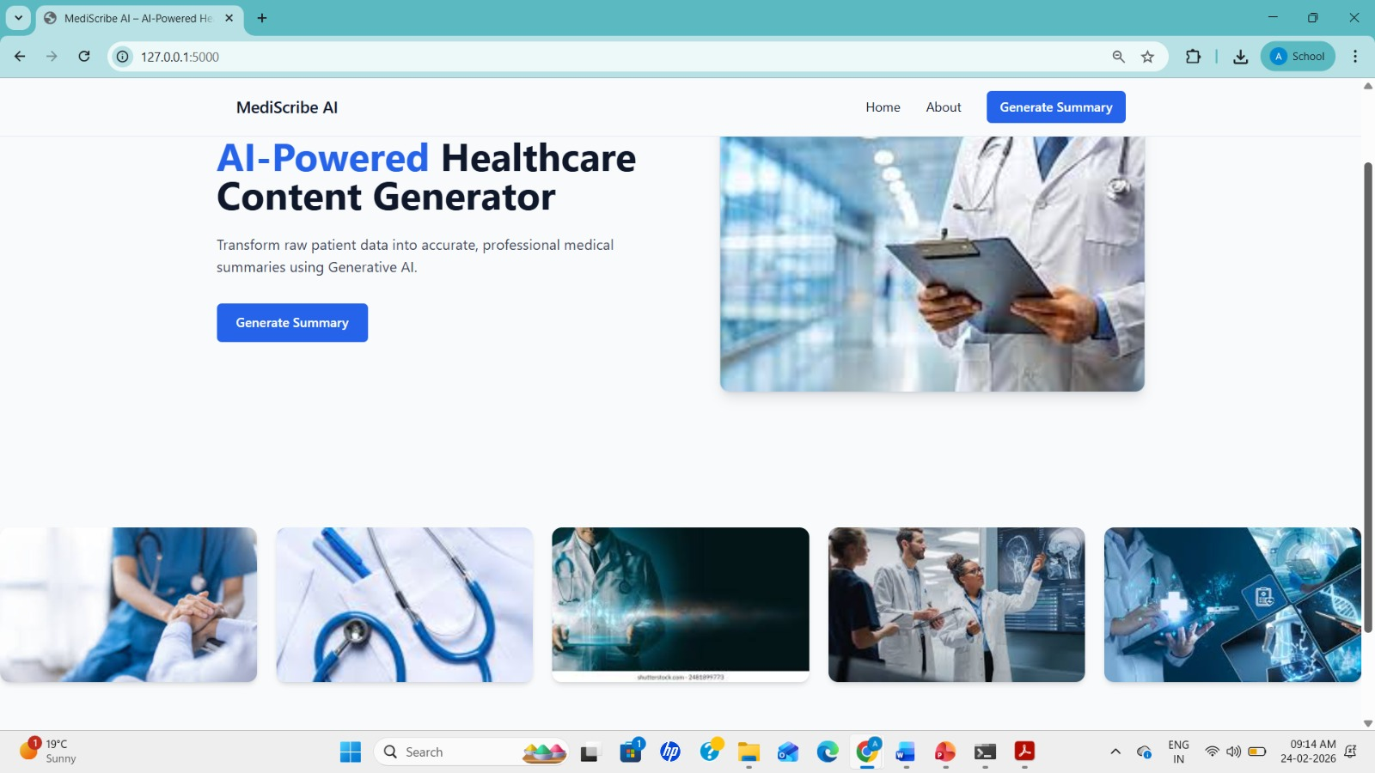

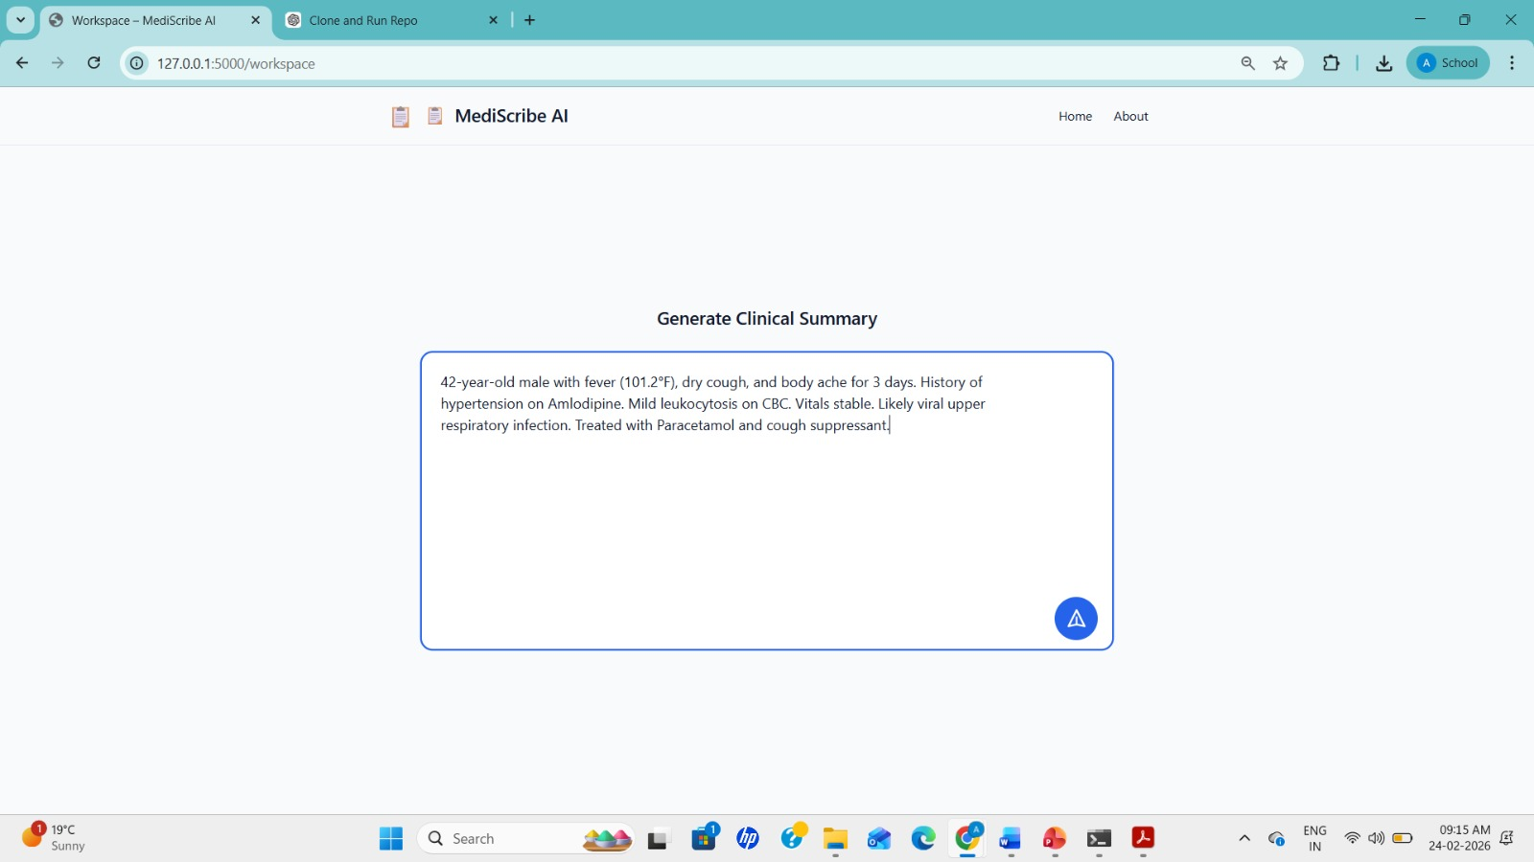

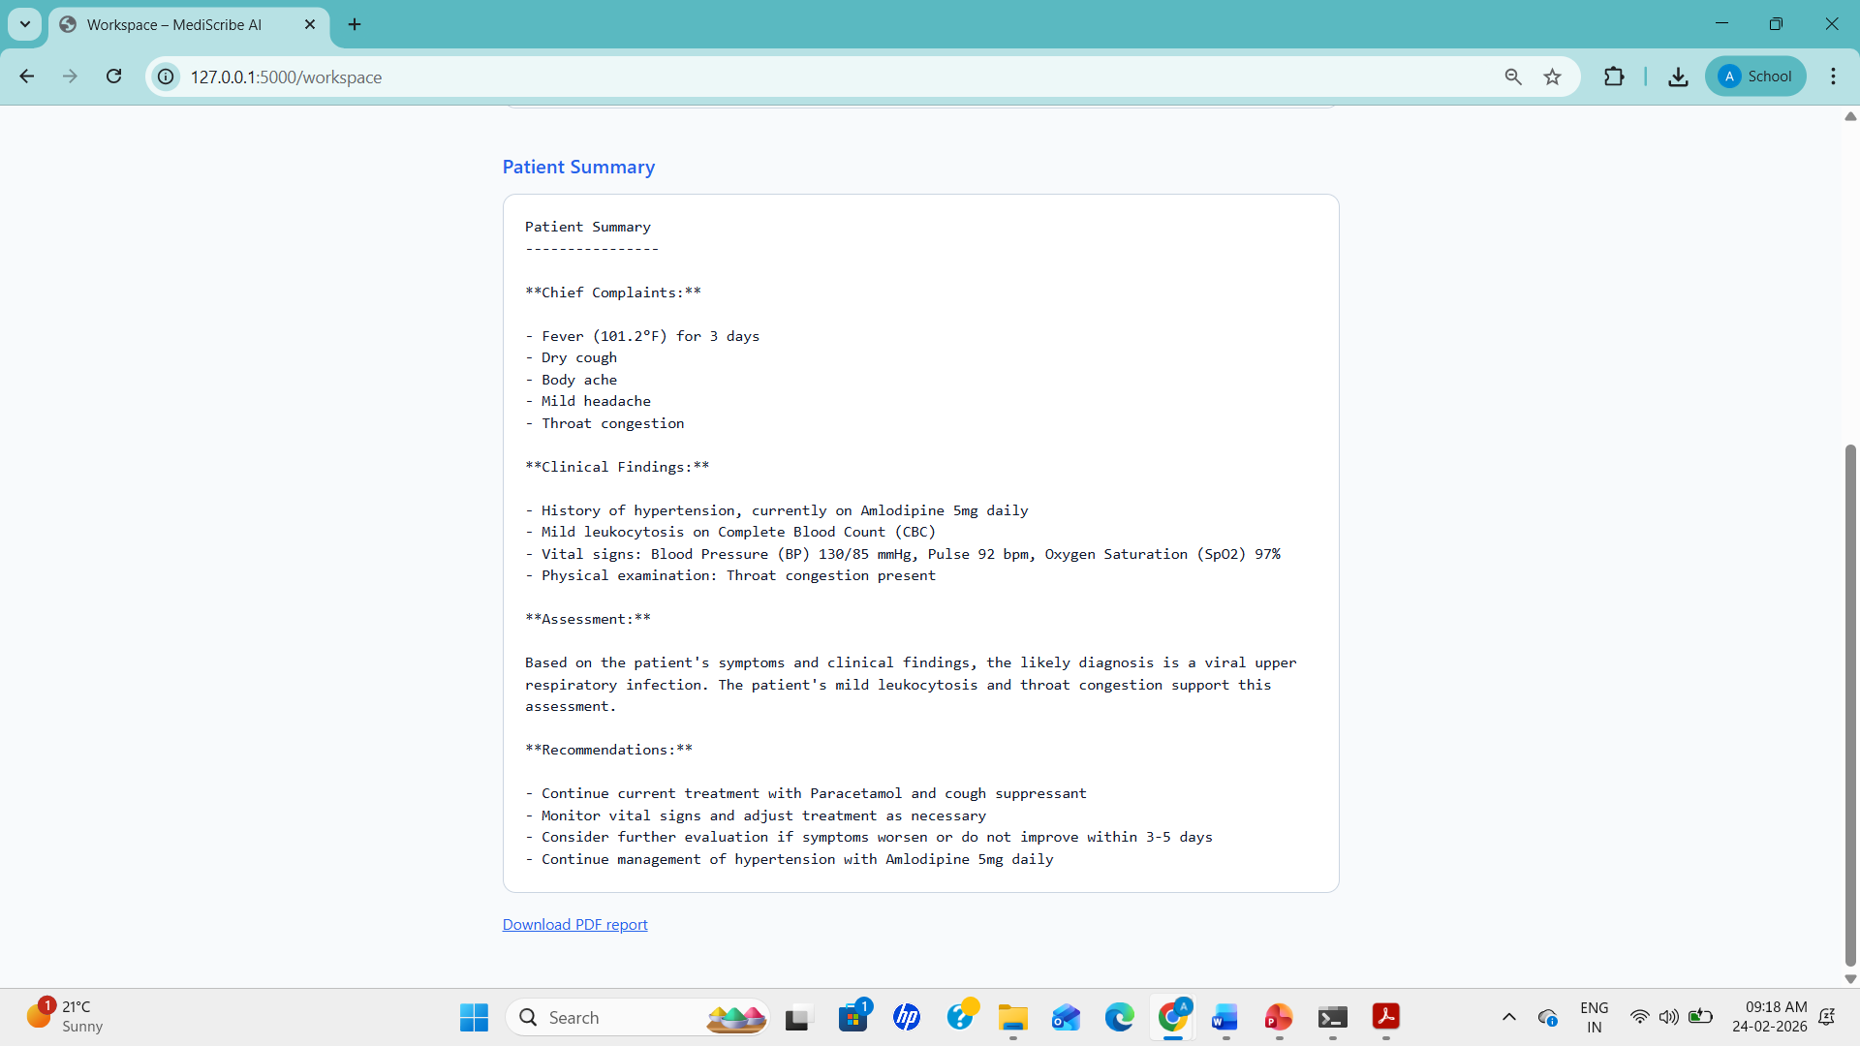
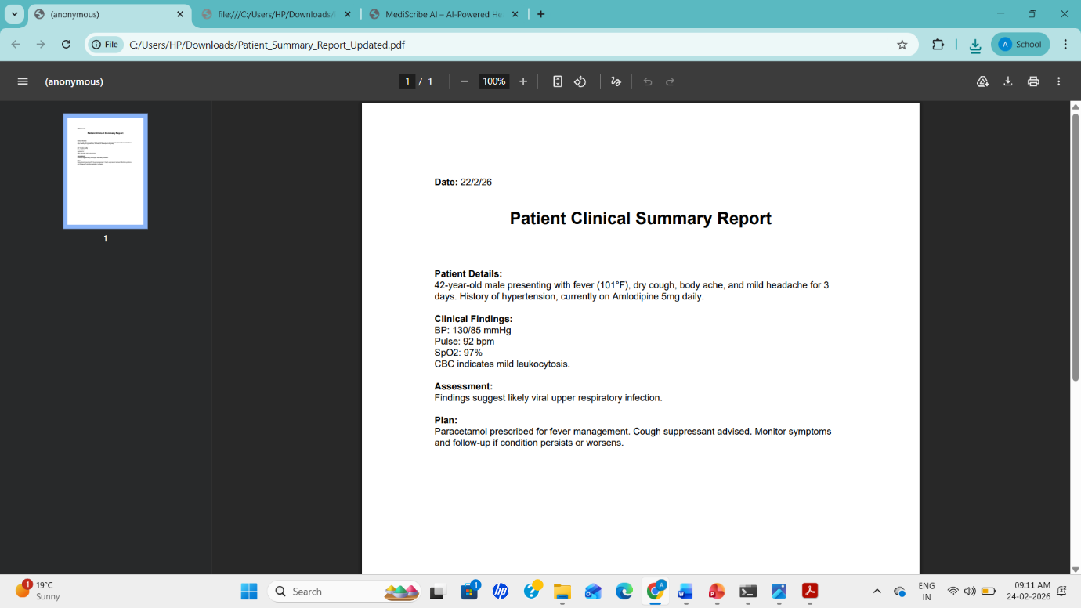

AI-Generated Outputs
- Structured Patient Summary
- Clinical Documentation Draft

- Professional Medical Report
The system successfully generates structured summaries using professional terminology and predefined headings.
Key Outcomes
- Reduced clinical documentation time significantly.
- Improved consistency and formatting in medical reports.
- Enabled structured AI-assisted documentation.
- Demonstrated practical use of Generative AI in healthcare.
- Implemented RAG architecture successfully.

Conclusion
MediScribe AI demonstrates how Generative AI can streamline healthcare documentation workflows. The system:
- Converts raw clinical input into structured medical summaries.
- Maintains professional tone and consistent formatting.
- Uses vector database retrieval for contextual accuracy.
- Reduces documentation burden on healthcare professionals.
This project highlights the real-world impact of AI-driven automation in medical environments and provides valuable hands-on experience in prompt engineering, LLM integration, vector databases, and scalable system design.The integration of the Groq API with the Meta LLaMA 3 model ensures efficient, high-performance AI processing. This enables real-time generation of structured medical summaries while maintaining professional medical standards and contextual accuracy.

Future Scope & Enhancements
- Integration with Electronic Health Record (EHR) systems
- Support for multilingual medical documentation
- HIPAA/GDPR compliant deployment model
- Advanced analytics dashboard for patient insights
- Voice-to-text integration for doctors

- Secure cloud deployment for hospital-scale usage
- AI-based error detection and validation layer

